NEW MEXICO AGRICULTURAL LEADERSHIP PROGRAM
APPLICATION

Class 18: June 2026 – January 2028
DEADLINE: April 15, 2026

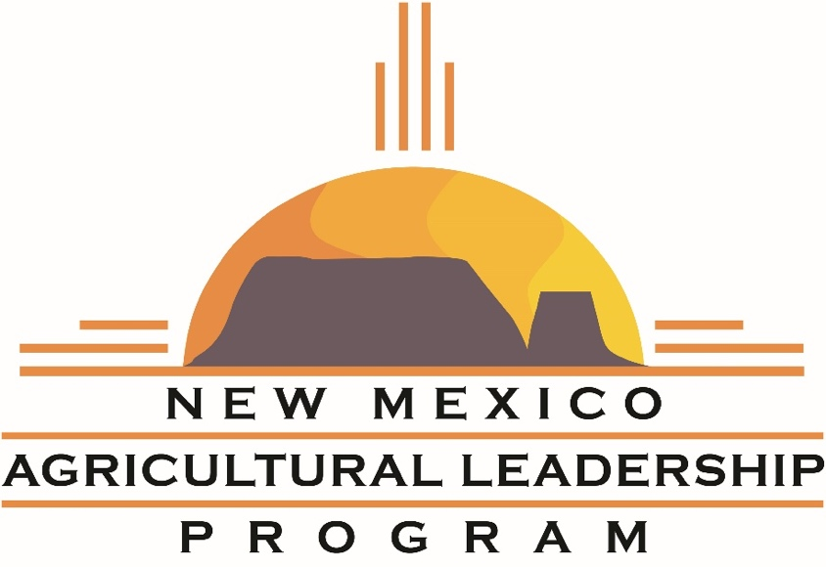

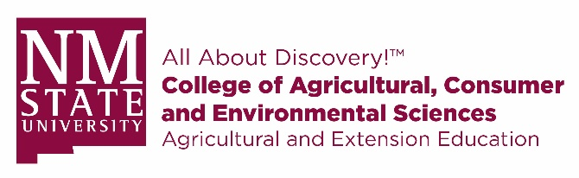

Send Completed Applications to:

New Mexico Agricultural Leadership
New Mexico State University
PO Box 30003 MSC 3501
Las Cruces, NM 88003-8003

Email: nmal@nmsu.edu

Questions?
Call Tina Wilson, Program Coordinator at 575-646-6691(office) or 402-321-9818 (cell)

Application Process
Candidates for NMAL will be evaluated on their potential for growth and learning, positive attitude, record of leadership (community service/involvement), character and reputation, potential for local contribution and state-wide impact, personal commitment and employer’s commitment.
Applicants must complete a written application and a short in-person interview. A selection committee will review completed applications and then extend an invitation to interview. This is an opportunity for applicants to ask questions and for the committee to evaluate potential for growth, motivation for professional development, and level of interest in the program.

Up to 15 applicants will be selected for each class.

Important Dates to Remember:
April 15, 2026 Application Deadline – mail, fax, or email ALL forms to the address on the front page
Mid-April to mid-May Interviews are conducted.
End of May Participants are notified of the selection
June 2026 Seminar #1 Las Cruces

Instructions for completing the application:
- Save the form to a location on your computer. (Example: Desktop or Documents).
- Open a Word document.
- Fill out your form:
Complete the form by clicking a text field and typing or adding a text box.
- Save your work often.
- Sign your form.
- Save your file and e-mail it to nmal@nmsu.edu.

Do not complete the form online within your web browser; your data will NOT be saved. Please save it to your computer first and then fill it out.
Checklist:
- Program Overview – read through for info on class schedule, tuition, etc.
- Application Form – Complete this fillable Word document with a signature page.
- Resume – Please send the most current resume with this document

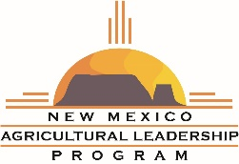
Personal Information

Full Name:
Preferred Name:
Date of Birth: Gender: Female ____ Male ____
Physical Address:
City: State: Zip Code:
Mailing Address (if different):
City: State: Zip Code:
Email:
Cell Phone: Alternative Phone:

Marital Status: Single ____ Married ____ Other ____
Spouse Full Name:
Email: ________________________________________________________________________
Cell Phone: _____________________
Names & ages of children:

Do you have a current Passport? Yes _____ No ______
International Destination Preferences:
- __________________________
- __________________________
Please list any dietary restrictions or food allergies:

Occupational Information

Employer/Company Name:
Mailing Address:
City: State: Zip Code:
Work Phone:
Current Position/Title:
Years in this position: Years with the company:
Employment Description/Responsibilities:

Please attach a current resume which includes both educational and work history
Industry Insight

Describe a critical issue facing your industry, and a specific idea you have for addressing it:

Describe an issue that is relevant to your community, or to New Mexico in general, and a specific idea you have for addressing it:

Community Service & Leadership

ORGANIZATIONS
List any organizations in which you have been a member, including years of membership and any offices/committee positions held:

COMMUNITY SERVICE
List any volunteer experience, including project names and dates of service:

HONORS & AWARDS
Please list any honors or awards you have received professionally, through a membership organization, or for your volunteer service:

Personal Interests

Please share a few of your hobbies or interests:

List any books, articles, movies, speakers, or associates who have given you useful insights this year – what did you learn?

Briefly describe your national and foreign travel experience, if any:

Destination | Purpose | Date / Length of Trip
Program Questions

How did you learn about NMAL? If you personally know a former participant, please give their name:

In your opinion, what attributes should a 21st century leader have?

Describe how you see yourself as a mentor/coach of others:

Describe your leadership potential - where do you have the capacity to lead, and how will you get there?

Why do you want to be a participant in the New Mexico Agricultural Leadership program?

Please add any additionally information you would like the selection committee to know:

References

Name of Applicant __________________________________________

Please list 3 references below (at least 2 professional).
Replies are confidential.

Reference #1

Name:

Company:

Position/Title:

Mailing Address: City/State/Zip:

Phone: Email:

Reference #2

Name:

Company:

Position/Title:

Mailing Address: City/State/Zip:

Phone: Email:

Reference #3

Name:

Company:

Position/Title:

Mailing Address: City/State/Zip:

Phone: Email: ______

Applicant Agreement

I am aware that participation in the New Mexico Agricultural Leadership program (NMAL) requires tuition of $3,500 U.S. dollars, payable to the program by either check or Visa/MasterCard and is not refundable. I agree to pay a minimum of $1,500 toward tuition by the start of the first seminar.

I am aware that the tuition fee does not include the cost of transportation to and from NMAL seminars, meals, and lodging.

I have read, understood, and agree to abide by the application packet's expectations, responsibilities, and requirements, including the commitment to participate fully in all seminars, conference calls, and class activities. This means that I will only use my cell phone, tablet, or laptop during seminar sessions if the facilitator requests. I understand there will be established seminar breaks when I can use these devices.

I agree to set aside time outside of formal sessions to prepare for seminars and study tours and to complete all projects and reading assignments in a timely manner.

I understand that this program is invested in by both public and private sources and that, as a graduate, I must commit to exercising my leadership skills within the agriculture, food, and natural resource industries.

If selected, I am willing to be a proactive ambassador for the NMAL program and consider contributing my time, talent, and funds to support it and assist with fundraising activities, recruitment, and promotion.

I permit NMAL to contact the references supplied. I understand that the selection of applicants is the sole responsibility of the organization and program Selection Committee.

By returning the completed application, I confirm my agreement to adhere to program expectations and certify that the statements made in this application are accurate and complete.

Applicant’s Name (Printed):

Applicant’s Signature: Date:

PHOTO RELEASE: I hereby give New Mexico State University irrevocable rights and permission to use, publish, and retain copyright to any images, photographs, video, audio, and other likenesses of the participant, as named above, for all media and all forms. I hereby release New Mexico State University from all claims, including libel and invasion of privacy, resulting from using the aforementioned images.

Signature of Applicant

